Mohidin Hassan

Maria Terrazas

CDS 301-001

05/21/2020

**Comparison Between Fairfax County and Russell County 2018 Traffic**

**Abstract**

Russell County and Fairfax County are both located in the Commonwealth of Virginia. Fairfax County is one of the largest counties in America, with the currently estimated population at around 1,167,000 whereas Russell County is a small rural area with a current population around 26,700. We thought it would be interesting to compare and contrast these two areas’ traffic density of different types of vehicles along with any prominent patterns among the two areas and also compare traffic volumes based on the type of days applied.

1. **Introduction/Background**

The first vehicles were developed in the late 1700s and were powered using steam which has been an energy source that had been used for many years at the time to power trains. The first electrical car in the United States was built in 1890 by William Morrison. As time went on, the vehicles improved and became more practical. In 1898, the first hybrid vehicle powered by electricity and gas was created by Ferdinand Porsche which became something revolutionary. It was Karl Benz who invented the first gas-powered car in 1885 but at the time, the vehicle had only three wheels. The invention of the gas-powered automobile was so drastically important in America that it became the beginning of vehicular evolution in America. As time progressed, the automobile changed drastically, new additions were added like seatbelts, windshields, speedometers, etc. At the time the late 80s-90s hit, automobiles became modernized thanks to the advancement of technology, they had electric windows, doors, sunroofs and as well as CD players. Did you know, the first turn signals were not added until 1939? Even though there have been roads for thousands of years for horses and oxen to pull wagons, vehicles made an impact to modernize the roads so early cars traveled these roads. Where there are vehicles, there is traffic, so all America’s traffic increased as vehicles were being sold and utilized everywhere.

The first place we are exploring is Fairfax County, which is at the heart of Northern Virginia with a population of around 1.16 million people. The area of Fairfax County is 406 square miles, has a median age of 38 and a median household income of $122,227. The population of Fairfax County is 50.1% White, 19.2% Asian, 16.4 Hispanic and the average commute time is 30.2 minutes and the average car ownership is 2 cars per household.

The other place we’re exploring is Russell County, which is a mountainous area located in Southwest Virginia with a population of around 26,700 people. The area of Russell County is 477 square miles with a median age of 44.8 and median household income of $40,083. The population of Russell County consists of 96.8% White, 1.27% Hispanic, 0.941 African American and the average commute time is 27.1 minutes. And the average car ownership in Russell County is 3 cars per household.

Both differ drastically in population volume based on location. We are using the Virginia Department of Transportation traffic data narrowed down to the year 2018 to stay consistent with the timeframe. This data has columns for each road and annual traffic volumes by vehicle type as well as several other data points.

1. **Methodology**

We searched for data on Fairfax and Russell County using data from the Virginia

Department of Transportation (VDOT) and other sources such as datausa.io and virginia.org.

1. **Analysis**
2. **Fairfax County**
3. **Background & History**

In 2018, Fairfax County had a population of around 1.15 million people, making around 13% of Virginia’s total population, with a median age of around 38 years old. It is the most populous counties in all of Virginia.

Fairfax was formed in 1742 and it was named after Thomas Fairfax, who was the “6th Lord Fairfax of Cameron”. Loudoun County, Arlington County, Falls Church were all a part of Fairfax County until 1757 when Loudoun County separated from Fairfax County, in 1789 when Alexandria County (renamed Arlington County in 1920) ceded from Fairfax, and in 1948 when Falls Church became an independent city.

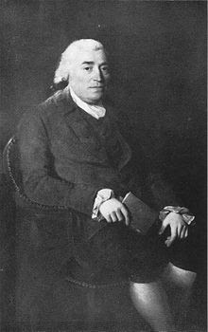

Thomas Fairfax

(Source:[https://upload.wikimedia.org/wikipedia/commons/thumb/4/45/ThomasFairfax6th.jpg/440px-ThomasFairfax6th.jpg](https://www.google.com/url?q=https://www.google.com/url?q%3Dhttps://upload.wikimedia.org/wikipedia/commons/thumb/4/45/ThomasFairfax6th.jpg/440px-ThomasFairfax6th.jpg%26amp;sa%3DD%26amp;ust%3D1590115272041000&sa=D&ust=1590115272092000&usg=AFQjCNFpGF2pQuOSTrYHtGB_I6l7SHe31Q))

1. **Commuting**

Fairfax’s average commute time is around 30 minutes, slightly longer than the average commute time in the US (around 25 minutes).

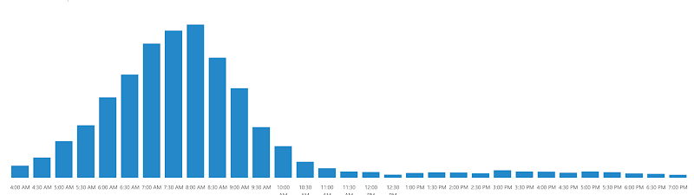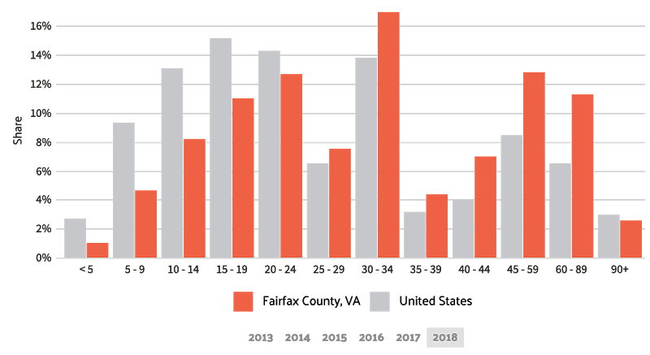

Most people who commuted preferred to drive alone with around 71% of people preferring to drive alone followed by around 10% of people preferring to commute using public transit. Around 9% of people preferred to travel by carpool.

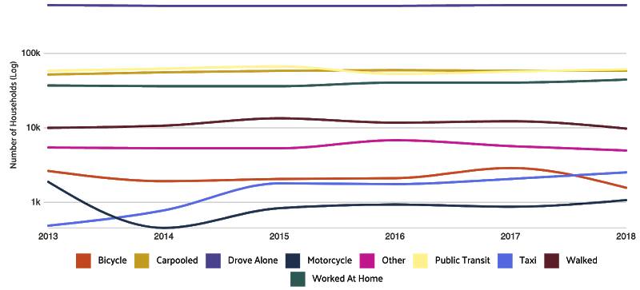

Source: [https://datausa.io/profile/geo/fairfax-county-va](https://www.google.com/url?q=https://www.google.com/url?q%3Dhttps://datausa.io/profile/geo/fairfax-county-va%26amp;sa%3DD%26amp;ust%3D1590115272043000&sa=D&ust=1590115272093000&usg=AFQjCNEkoZ_yICtGSNbemg1Hho7Qnz4t8g)

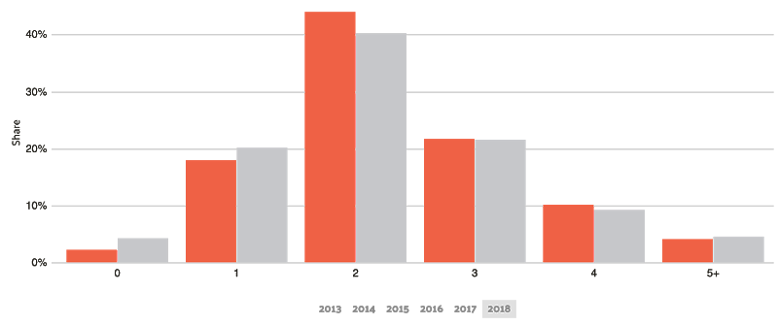

Source: [https://datausa.io/profile/geo/fairfax-county-va](https://www.google.com/url?q=https://www.google.com/url?q%3Dhttps://datausa.io/profile/geo/fairfax-county-va%26amp;sa%3DD%26amp;ust%3D1590115272044000&sa=D&ust=1590115272093000&usg=AFQjCNHBkP_xJuDHueL40nFsDtMrcqfrUw) (Left: Fairfax County, Right: USA)

For the traffic, a majority of the traffic in Fairfax County goes through the I-95 route towards Washington D.C. and also towards places like Alexandria, VA and Mclean, VA.

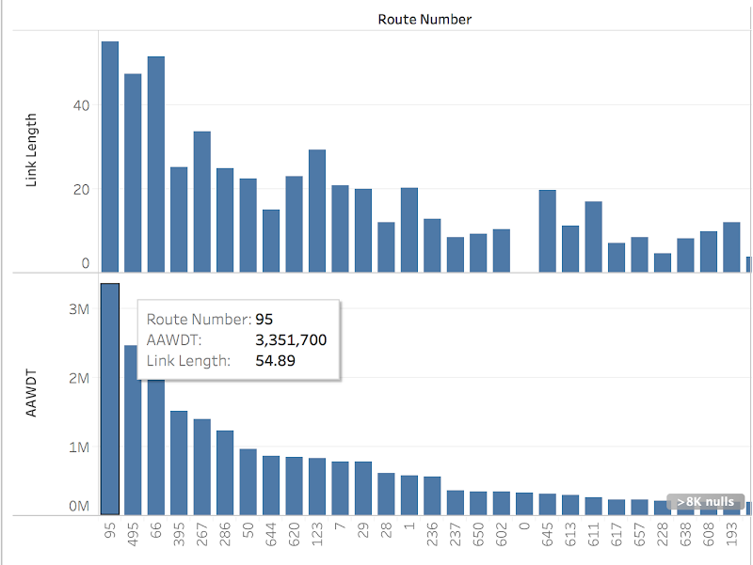

The majority the traffic came from 4-wheel vehicles whereas some of the traffic came from other vehicles like trucks and buses

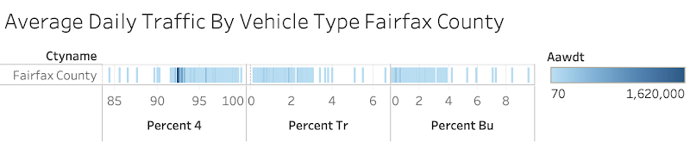

1. **Economy**

Fairfax is one of the highest earning regions in the US, with the average household earning roughly $122,000, followed by Loudoun County, Arlington County, and Falls Church with the highest income in the upper part of Fairfax.

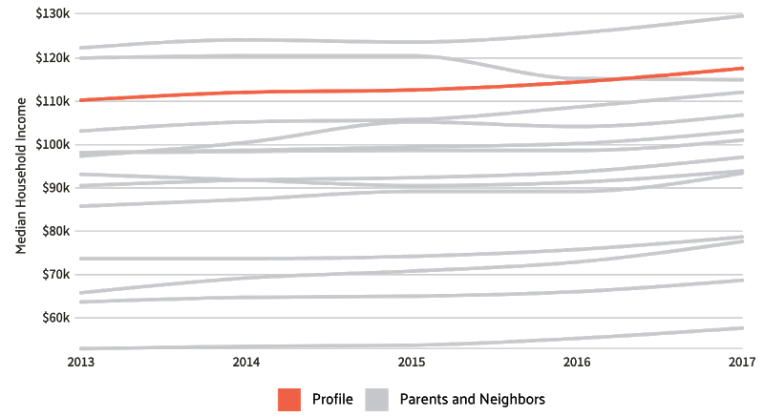

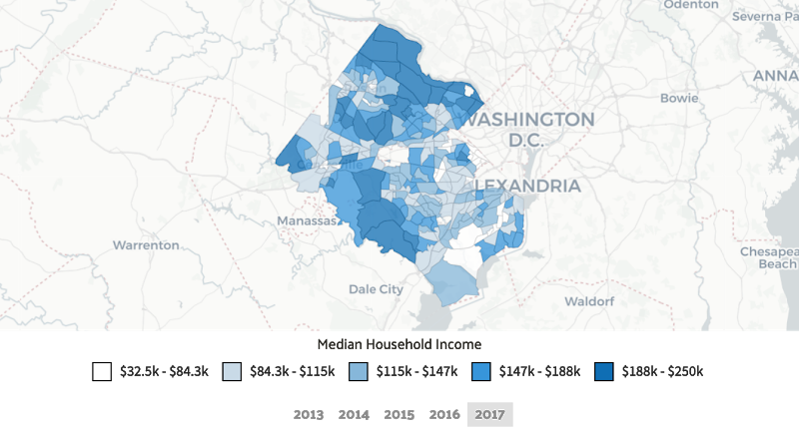

1. **Population Demographics**

For the demographics in Fairfax, the median age for native-born citizens is around 38 years old whereas the average age for foreign-born citizens is around 45 years old.The majority of the population consists of the white.

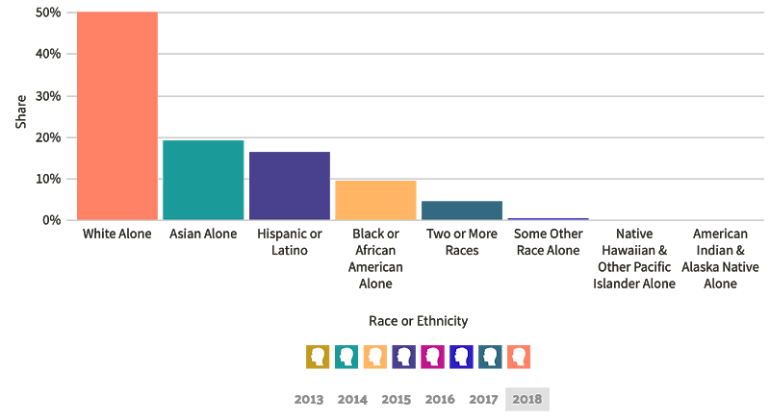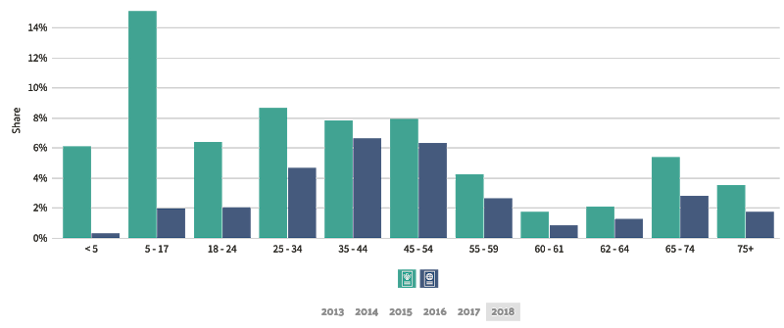

1. **Russell County**

1. **Background & History**

The landscape of Russell County is more rugged and mountainous than Fairfax County, but because of this it was described by the Nature Conservancy, an environmental group dedicated to conserving the lands and waters of the world , as “one of the last great places”. Russell County was established by Colonel William Russell from a section of Washington County in 1786.

1. **Commute**

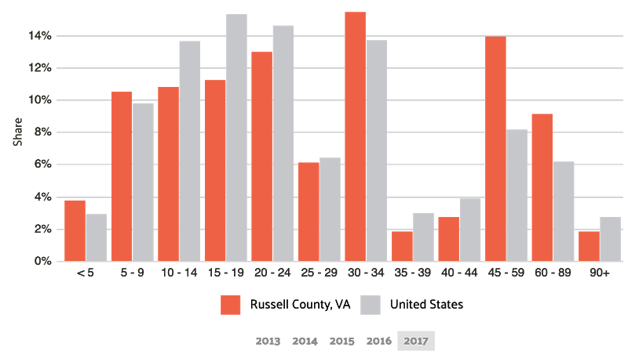The average commute time in Russell County is roughly 27 minutes, slightly longer than the average commute time in the US. The most common method of transportation was by driving alone with around 88% of commuters preferring this, followed by roughly 7% of people preferring to carpool.

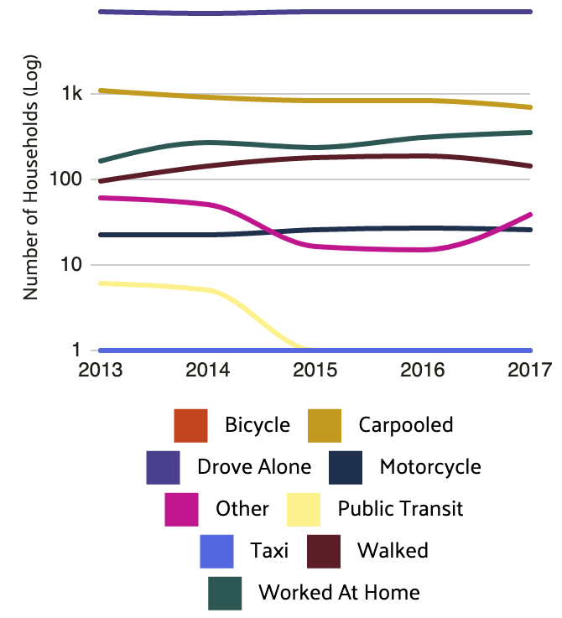Source: [https://datausa.io/profile/geo/russell-county-va](https://www.google.com/url?q=https://www.google.com/url?q%3Dhttps://datausa.io/profile/geo/russell-county-va%26amp;sa%3DD%26amp;ust%3D1590115272048000&sa=D&ust=1590115272096000&usg=AFQjCNHC63Kl0b0Id7TJhlff2e1a4oiZXQ)

Source: [https://datausa.io/profile/geo/russell-county-va](https://www.google.com/url?q=https://www.google.com/url?q%3Dhttps://datausa.io/profile/geo/russell-county-va%26amp;sa%3DD%26amp;ust%3D1590115272049000&sa=D&ust=1590115272097000&usg=AFQjCNHfzZm_SVGzu1a9dBq0Nx-M3Vi5Fw)

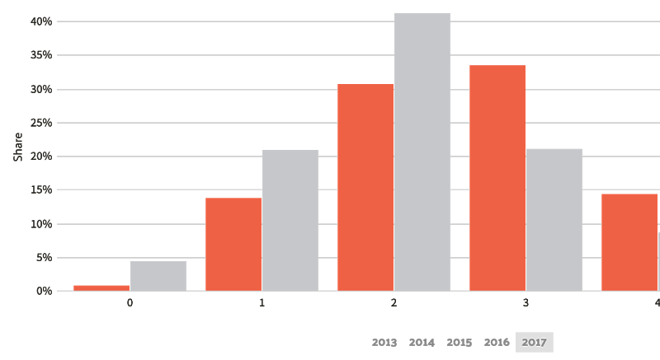

Source: [https://datausa.io/profile/geo/russell-county-va](https://www.google.com/url?q=https://www.google.com/url?q%3Dhttps://datausa.io/profile/geo/russell-county-va%26amp;sa%3DD%26amp;ust%3D1590115272049000&sa=D&ust=1590115272097000&usg=AFQjCNHfzZm_SVGzu1a9dBq0Nx-M3Vi5Fw)

As you can see here, there isn’t a whole lot of traffic in Russell County and that’s because it is a mountainous area. Just like Fairfax, most of the traffic comes from 4-wheeled vehicles.

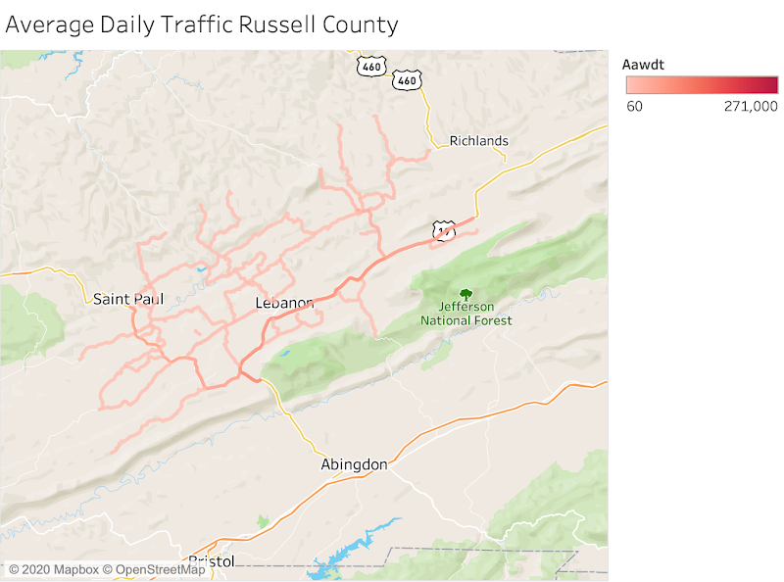

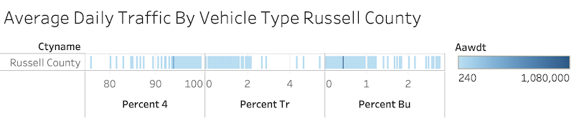

Source: [https://datausa.io/profile/geo/russell-county-va](https://www.google.com/url?q=https://www.google.com/url?q%3Dhttps://datausa.io/profile/geo/russell-county-va%26amp;sa%3DD%26amp;ust%3D1590115272050000&sa=D&ust=1590115272098000&usg=AFQjCNE9SsHKCxjceklx8VGh36hvdPjaSw)

1. **Economy**

Russell County’s average household earns roughly $40,083, with the highest income in the middle area of Russell County.

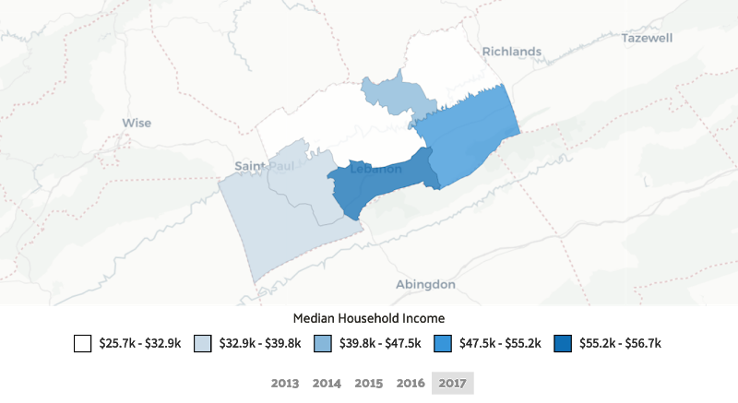Source: [https://datausa.io/profile/geo/russell-county-va](https://www.google.com/url?q=https://www.google.com/url?q%3Dhttps://datausa.io/profile/geo/russell-county-va%26amp;sa%3DD%26amp;ust%3D1590115272051000&sa=D&ust=1590115272098000&usg=AFQjCNFWzr0r955onIrTORll_rq5SB1joQ)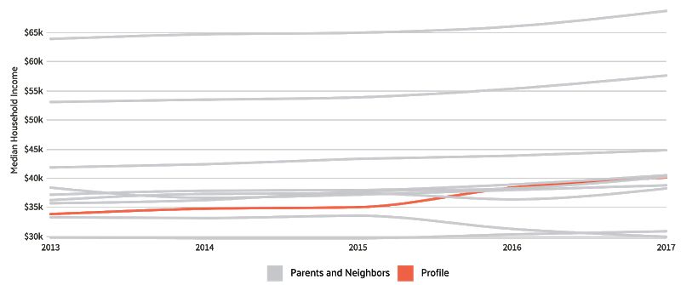

Source: [https://datausa.io/profile/geo/russell-county-va](https://www.google.com/url?q=https://www.google.com/url?q%3Dhttps://datausa.io/profile/geo/russell-county-va%26amp;sa%3DD%26amp;ust%3D1590115272051000&sa=D&ust=1590115272098000&usg=AFQjCNFWzr0r955onIrTORll_rq5SB1joQ)

1. **Population Demographics**

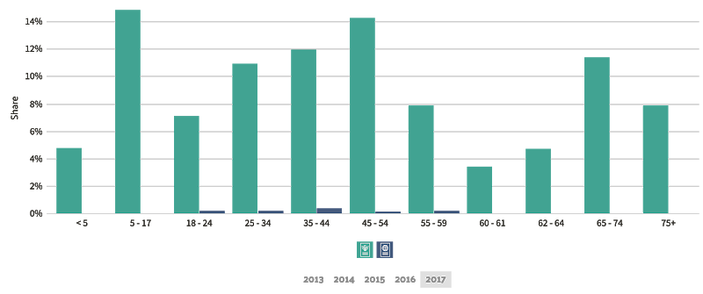For the demographics in Russell County, the median age for native-born citizens is around 45 years old whereas the average age for foreign-born citizens is around 38 years old.

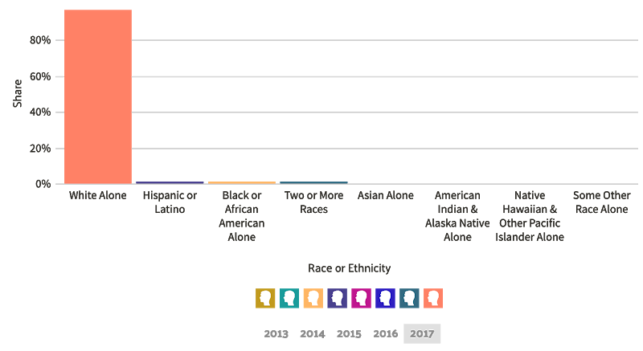Source: [https://datausa.io/profile/geo/russell-county-va](https://www.google.com/url?q=https://www.google.com/url?q%3Dhttps://datausa.io/profile/geo/russell-county-va%26amp;sa%3DD%26amp;ust%3D1590115272052000&sa=D&ust=1590115272099000&usg=AFQjCNFexdVTRS1bm0UpU8WHdG_PuCVZnA)

Source: [https://datausa.io/profile/geo/russell-county-va](https://www.google.com/url?q=https://www.google.com/url?q%3Dhttps://datausa.io/profile/geo/russell-county-va%26amp;sa%3DD%26amp;ust%3D1590115272053000&sa=D&ust=1590115272099000&usg=AFQjCNF7SnK_cw51BEdexiZ0pfv6nmUUKg)

1. 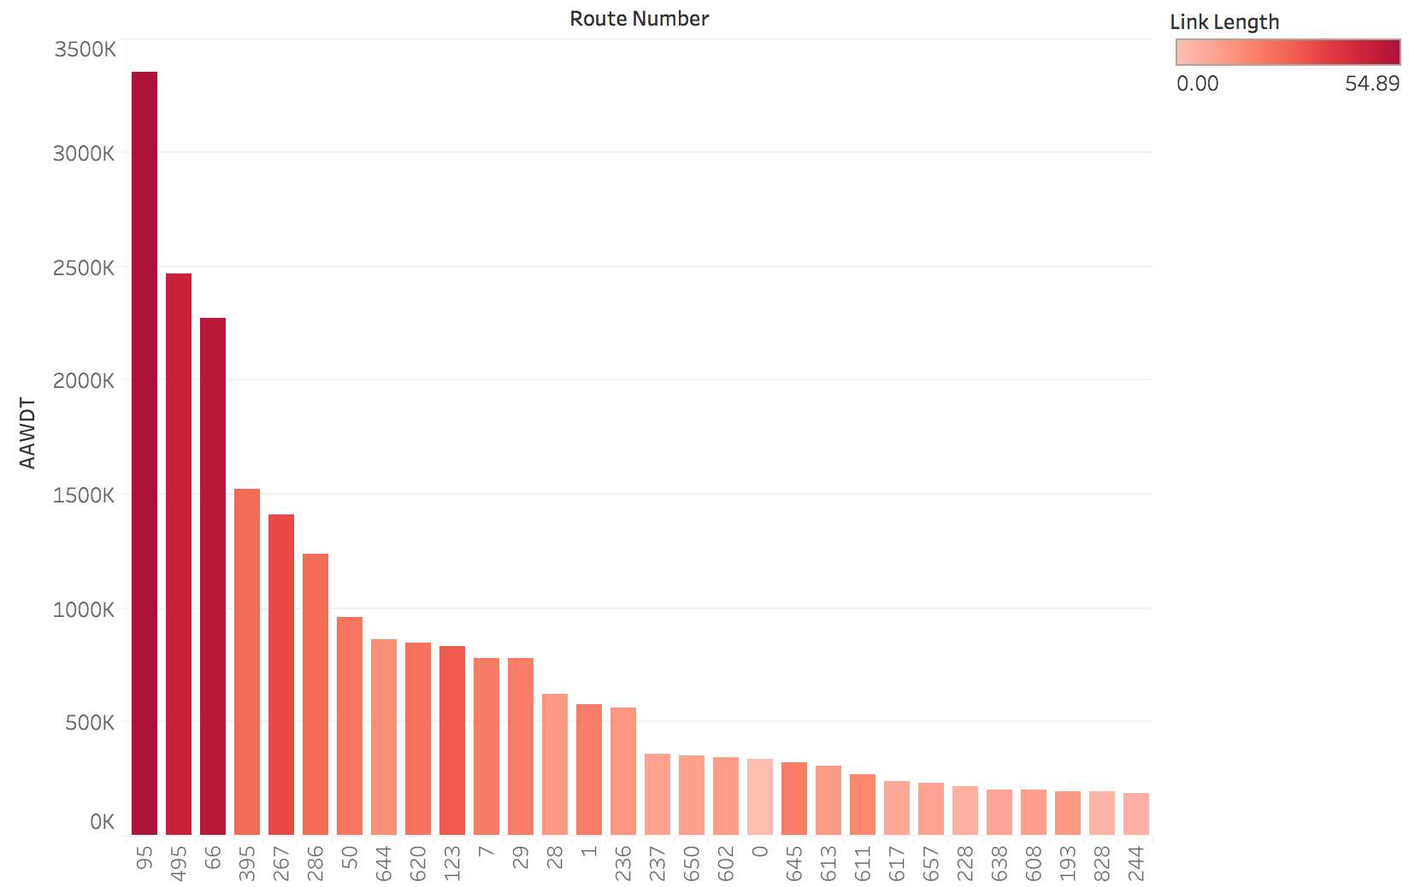**Comparison between Fairfax County and Russell County traffic**

This graph shows the AAWDT for Fairfax County on the twenty most travelled route. The bars are also colored based on the length of the road showing that the darker red colors are the longer segments of roads. We can see a clear positive relationship between road length and amount of traffic. Another trend to note is that major highways and thoroughfares have significantly more traffic.

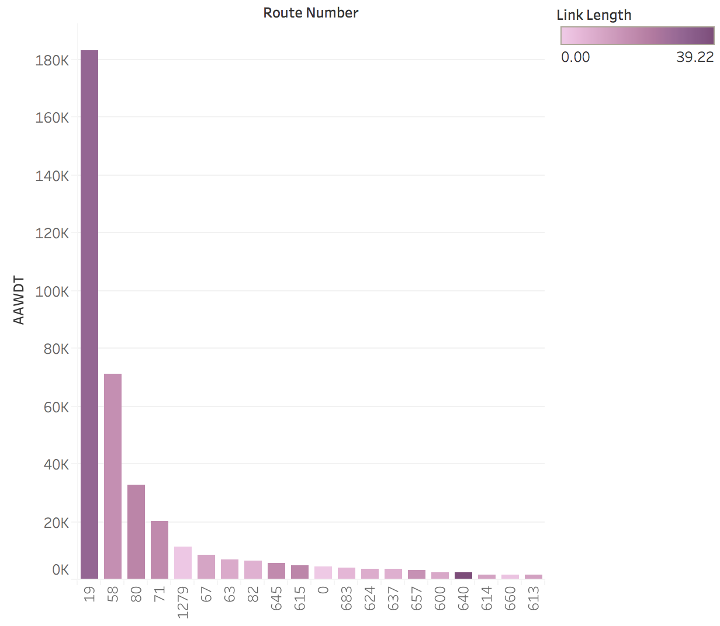

The second graph shows the AAWDT for Russell County on the twenty most travelled routes. The bars are also colored based on the length of road showing that the darker purple colors indicate a longer road length. It is very difficult to find a relationship between road length and traffic as some of the shortest routes have a disproportionately sized traffic amount. The routes 19 and 58 have the highest traffic amounts and this is probably due to being the major through routes for traveling through Russell County and much of the traffic may not be local.

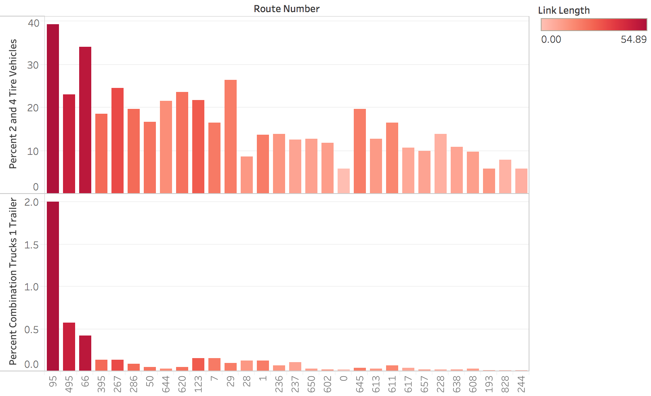

This graph shows the percentage of traffic that is represented by 2 and 4 tire vehicles, and single trailer trucks. For the both types of vehicles the data is heavily skewed towards the major highways further reinforcing that major transportation veins such as highways carry the largest proportion of traffic. In the case of single trailer trucks, they almost exclusively use the highways most likely due to the fact that they are not driving on local roads as their destination may not be in the Fairfax County interior, but rather they are just passing through onto their destination.

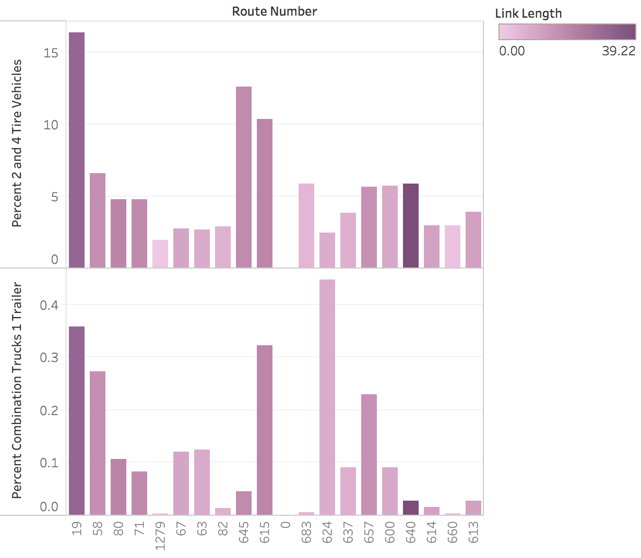

The fourth picture shows the percentage of traffic that is represented by 2 and 4 tire vehicles, and single trailer trucks. For the both types of vehicles the data is heavily skewed towards the major highways further reinforcing that major transportation veins such as highways carry the largest proportion of traffic. In the case of single trailer trucks, they are more evenly distributed among the routes in Russell County, excluding routes 19 and 58 as those routes are mostly likely used to cross Russell County, the data shows that these trucks are most likely making deliveries or stops within the County limits just as much as they are passing through the county.

1. **Conclusions**

        We have looked at and compared and contrasted both Fairfax and Russell Counties' traffic density of different types of vehicles along with any prominent patterns among the two areas and we also compared traffic volumes based on the type of days applied. We set out to try to find traffic patterns and differences in these traffic patterns between well populated areas and less populated areas. We found that as a general rule of thumb major highways and routes that span all the way across a county tend to be the most travelled. We suspect that this is due to a lot of non-local travel and that the counties are just passed by on these routes. These major routes are also carrying the largest amounts of single truck trailers as they transport their goods cross country. Russell County has a slight exception to this where the trucks were not mostly concentrated on the major routes but were in fact present on a lot of the minor routes too. This is most likely due to making deliveries and stops at the many locations in Russell County and since it is a small populace, there is not much 2 and 4 tire vehicle traffic to offset the ratio. We also found that in large counties the route length has a positive effect on traffic as these tend to major commuter routes with high volumes of traffic. The smaller counties though do not have such a clear relationship because it seems that route length has very little effect on traffic and what may be driving the traffic volumes could be popular restaurants, sectioned housing, grocery stores that are frequently visited, etc. Much of the conclusions we found are not very unexpected as anyone who has driven through large cities, highways, and small towns would have a basic idea of what they notice. Such as seeing trucks mostly on highways and small towns not really having large directing road networks to get drivers through efficiently since everything is so close together. Nonetheless, it was rewarding to be able to confirm much of our suspicions about traffic using real data and especially when it relates to us by being locally relevant data.

**Bibliography**

“Russell.” *Russell - Virginia Is For Lovers*, [www.virginia.org/counties/Russell](https://www.google.com/url?q=https://www.google.com/url?q%3Dhttp://www.virginia.org/counties/Russell%26amp;sa%3DD%26amp;ust%3D1590115272055000&sa=D&ust=1590115272101000&usg=AFQjCNGBiZrntVFm7NvahOYc8nY8rBsDPA).

“History: Russell County, VA.” *History | Russell County, VA*, [www.russellcountyva.us/199/History](https://www.google.com/url?q=https://www.google.com/url?q%3Dhttp://www.russellcountyva.us/199/History%26amp;sa%3DD%26amp;ust%3D1590115272056000&sa=D&ust=1590115272101000&usg=AFQjCNGZTLRgM5m4I9viNZUir_xhK7JN4A).

“Fairfax County.” *Fairfax County - Virginia Is For Lovers*, [www.virginia.org/counties/Fairfax/](https://www.google.com/url?q=https://www.google.com/url?q%3Dhttp://www.virginia.org/counties/Fairfax/%26amp;sa%3DD%26amp;ust%3D1590115272056000&sa=D&ust=1590115272101000&usg=AFQjCNH_ubzimDeD0S9T4Zf5TB4Lz8ogAw).

**Data Sources**

[https://www.fairfaxcounty.gov/demographics/commuting-patterns](https://www.google.com/url?q=https://www.google.com/url?q%3Dhttps://www.fairfaxcounty.gov/demographics/commuting-patterns%26amp;sa%3DD%26amp;ust%3D1590115272057000&sa=D&ust=1590115272101000&usg=AFQjCNH3HjWWpMXAF4HASMD8qLp_YDiofw)

[https://www.cppdc.com/Statistics/Russell%20County%20Profile.pdf](https://www.google.com/url?q=https://www.google.com/url?q%3Dhttps://www.cppdc.com/Statistics/Russell%252520County%252520Profile.pdf%26amp;sa%3DD%26amp;ust%3D1590115272057000&sa=D&ust=1590115272101000&usg=AFQjCNEOxx3rnkktvU2K229xbRbYRgLROQ)

[https://www.fairfaxcounty.gov/demographics/fairfax-county-general-overview](https://www.google.com/url?q=https://www.google.com/url?q%3Dhttps://www.fairfaxcounty.gov/demographics/fairfax-county-general-overview%26amp;sa%3DD%26amp;ust%3D1590115272057000&sa=D&ust=1590115272101000&usg=AFQjCNFRLDMal24mJnTRMmtd14-RMSXSbg)

[https://datausa.io/profile/geo/russell-county-va](https://www.google.com/url?q=https://www.google.com/url?q%3Dhttps://datausa.io/profile/geo/russell-county-va%26amp;sa%3DD%26amp;ust%3D1590115272058000&sa=D&ust=1590115272101000&usg=AFQjCNE6y0fuVu3JjMdoiwTVGWkkUmEA-w)

[https://datausa.io/profile/geo/fairfax-county-va](https://www.google.com/url?q=https://www.google.com/url?q%3Dhttps://datausa.io/profile/geo/fairfax-county-va%26amp;sa%3DD%26amp;ust%3D1590115272058000&sa=D&ust=1590115272102000&usg=AFQjCNEaL3BkvFyxjYTTf_fkUlYrhsJRgg)

[https://www.virginiadot.org/info/2018_traffic_data_by_jurisdiction.asp](https://www.google.com/url?q=https://www.google.com/url?q%3Dhttps://www.virginiadot.org/info/2018_traffic_data_by_jurisdiction.asp%26amp;sa%3DD%26amp;ust%3D1590115272058000&sa=D&ust=1590115272102000&usg=AFQjCNHLrlSC15nhm093jPzKAaYo8ShUAQ)